# W1

## What is an Enterprise System?

* enterprise-wide, modular, integrated, real time information system responsible for transaction processing across all business areas of the organisation
* made up of a series of “modules”, linked together through database, ERP system enables various departments
  + Accounting and Finance,
  + Human Resources,
  + Production
  + sales and Distribution to coordinate activities
* Key
  + Links all business processes
  + Reduces inter-processing time
  + Utilises a common database
  + Uses current technology
  + Performs internal conversions (tax, foreign currency)

## What is Real-time Enterprise?

* computer system that responds to transactions immediately updating the databases.
* systems generate response fast enough to prevent human waiting very long.

## What are the functions of enterprise systems?

* Brings together isolated information systems providing a more whole or complete information resource
* Achieve a common strategic business goal
* Originally systems
  + No connection with other systems
  + No sharing of data
  + Management had difficulty
  + Too many legacy systems
  + Not able to keep up with their competitors
  + Not agile enough to change direction

## What are the drivers for enterprise systems?

* Technology Rationales
  + Disparate Systems
  + Poor existing systems
  + Difficult to integrate
* Business Process
  + Personnel reduction
  + IT cost reduction
  + Revenue
  + Financial cycle close
  + Productivity Improvements
* Strategic Rationales
  + eBusiness
  + Added functionality
  + Response to mergers
* Competitive Rationales
  + Competitive pressures to become a low-cost producer

## What are the benefits of enterprise systems?

* Enhance all aspects of key operations
  + from planning through execution, management, and control
  + Accomplish this by taking processes and functions that seamlessly integrating and coordinating them
* more efficient completion of day-to-day tasks
* Reduce overlapping activities that waste time and money
* Eliminate data silos(孤岛) by creating a single, centralized repository of timely, accurate business data
* Enable more effective resource allocation and management.

## What is the “Sense-Analyse-Response” framework?

Enterprises need to have a 3-step framework

* “Sense” component - enables the enterprise know all external and internal information that is relevant
* “Analyse” component - helps analyse the information, identify patterns, forecast and predict impacts and consequences
* “Respond” component - determines the best possible response based on the analysis and executes the response

## What are the characteristics of real-time enterprise systems?

* Agility – to meet the time- to-market requirements
* Available anywhere anytime – business processes need to enable customers, partners and employees to use, participate and be productive from anywhere and anytime.
* Scalable – to deal with such large volumes and wide varieties of data.
* Intelligent – designed to leverage predictive analytics and machine learning capabilities
* Collaboration Driven – designed to leverage the collective wisdom of all the stakeholders and for collaboration
* Low Latency – enable near real time processing and responses

# W2

## Describe the main functional areas of operation used in business

* Functional areas interdependent
* Better integration of functional improvements communication, workflow, and success of company

## Differentiate between a business process and a business function

Processes transform inputs into services and goods, while functions are specific to a particular area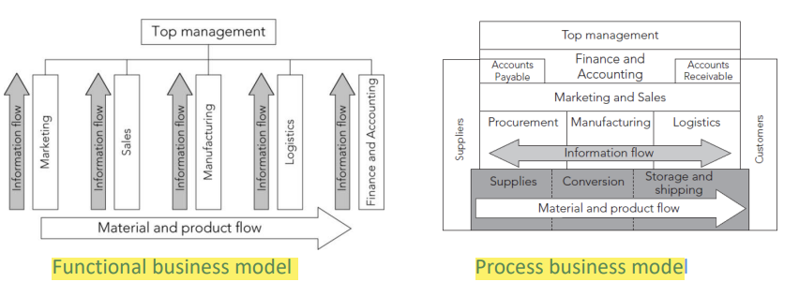

### Functional Areas

* Marketing and Sales (M/S)
  + Functions:
    - Developing products
    - Pricing
      * determined based on a product’s unit cost
      * Requires information A/F, and SCM data
    - Promoting
    - Taking orders
    - sales forecast
  + Needs information from all areas
  + Inputs
    - Customer data
    - Order data
    - Sales trend data
    - Per-unit cost
    - Company travels expense policy
  + Outputs
    - Sales strategies
    - Product pricing
    - Employment needs

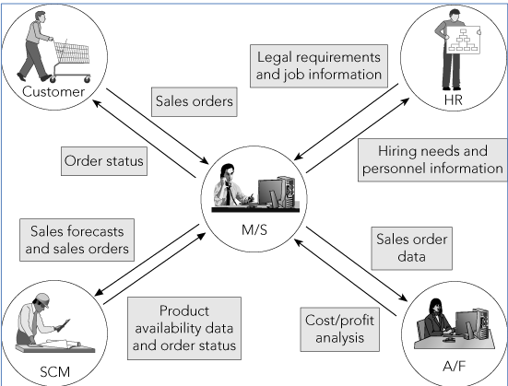

* Supply Chain Management (SCM)
  + Production plans based on information about product sales from M/F
  + Minimize of stock
  + Provide data to Accounting and Finance - each resource was used
  + Support the M/S function by information about what has been produced and shipped – eg customer know where is my coffee
  + Inputs
    - – Product sales data
    - – Production plans
    - – Inventory levels
    - – Layoff and recall company policy
  + Outputs
    - – Raw material orders
    - – Packaging orders
    - – Resource expenditure data
    - – Production and inventory reports
    - – Hiring information
  + 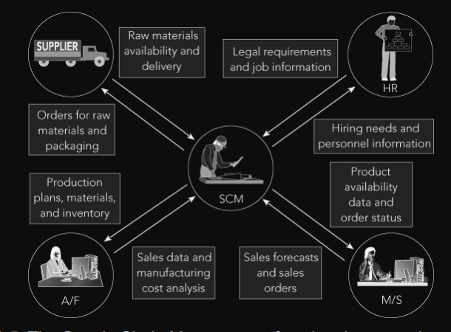
* Accounting and Finance (A/F)
  + Recording raw data about transactions- material purchases, payroll, and receipt of cash
  + Raw data: Numbers collected from sales without any manipulation, calculation, or arrangement for presentation
  + Records important component of sales forecast
  + making staffing decisions and in production planning
  + personnel
    - Record transactions
    - Record accounts payable when raw materials are purchased and cash outflows
    - Summarize transaction prepare reports
  + Inputs
    - – Payments from customers
    - – Accounts receivable data
    - – Accounts payable data
    - – Sales data
    - – Production and inventory data
    - – Payroll and expense data
  + Outputs
    - – Payments to suppliers
    - – Financial reports
    - – Customer credit data
  + 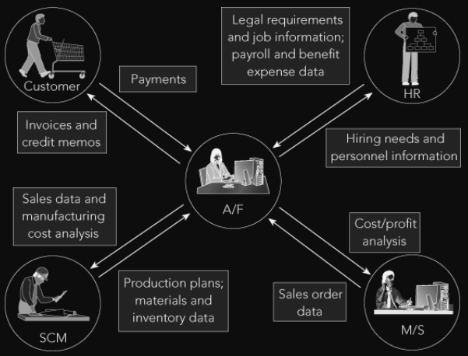
* Human Resources (HR)
  + Recruit, train, evaluate, and compensate employees
  + uses sales forecasts to plan personnel needs
  + Tasks related to employee hiring, benefits, training, and government compliance
  + accurate forecasts of personnel needs
  + know what skills are needed to perform a particular job
  + Inputs
    - – Personnel forecasts
    - – Skills data
  + Outputs
    - – Regulation compliance
    - – Employee training and certification
    - – Skills database
    - – Employee evaluation and compensation
  + 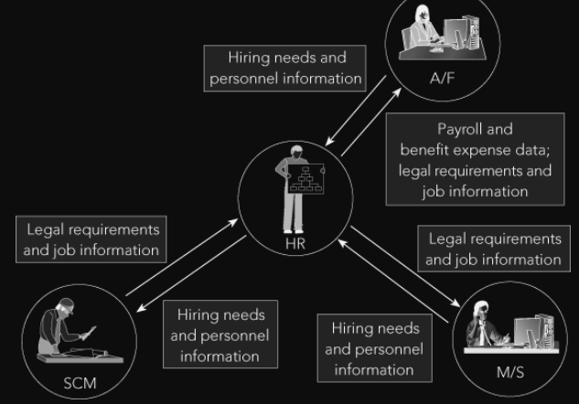

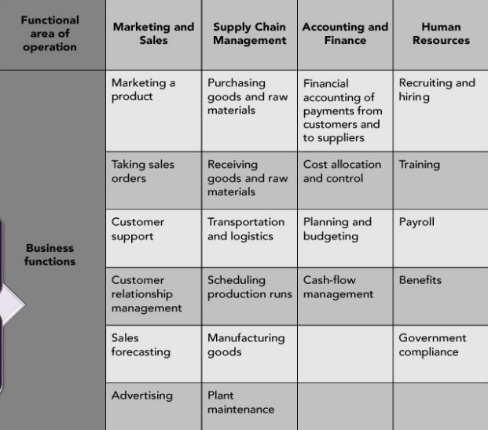

* Functional areas are interdependent
* Better integration of functional improvements communication, workflow, and success of company

### Business Processes

* Collection of activities input and creates an output that is of value to customer (Traditional external customer or internal customer)
* Thinking in terms of business processes helps managers to look at their organisation from the customer’s perspective

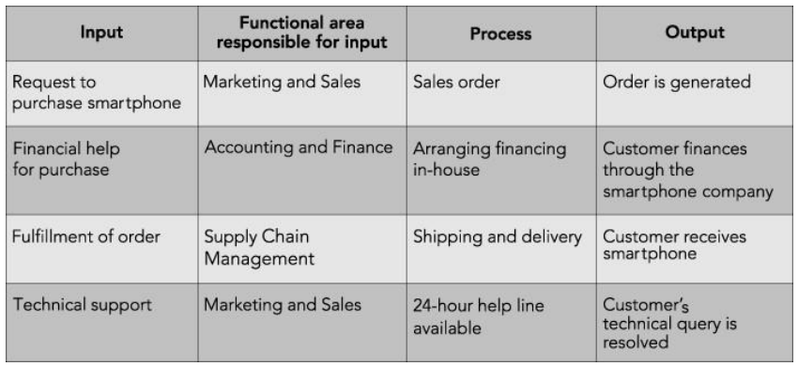

* Businesses consider customer’s viewpoint in any transaction
* Successful customer interaction: interact with each business function involved in the process
* Successful business managers view business operations from the perspective of a satisfied customer
* Sharing data effectively within functional areas leads to more efficient business processes
* Integrated information systems: all functional areas share data
* Managing business processes effectively requires accurate and up-to-date information

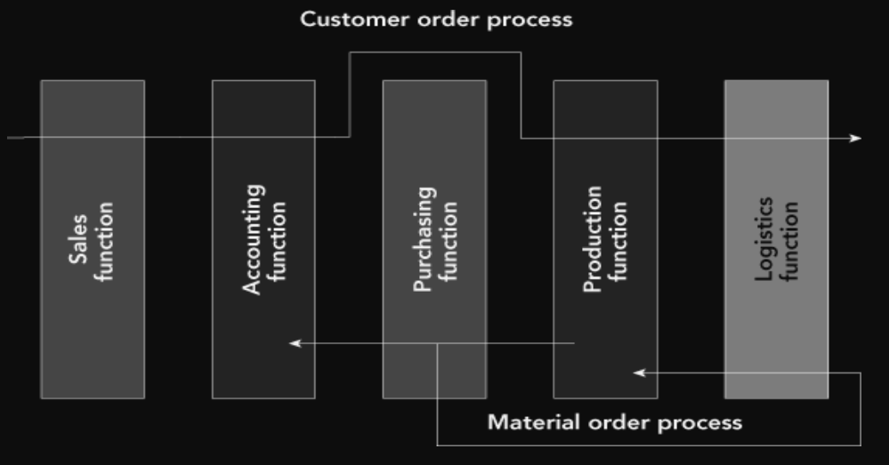

## Define integrated information systems, and explain why they are essential in today’s globally competitive business environment

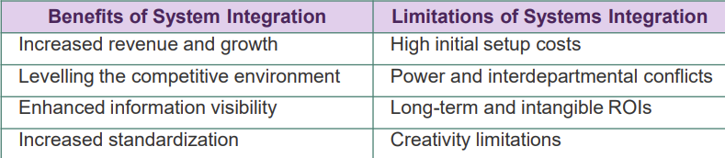

* (ERP) systems are integrated, multi-module application software packages designed to serve and support several businesses across an organisation
* enabling systems integration at various levels of the application architecture
* allow companies respond quickly to market conditions
* At the logical level
  + ERP systems require organisations to focus on business process rather than on functions
  + systems allow organisations to share data with all of its stakeholders based on their need and authorisation
* At the physical level
  + install an ERP system have to upgrade or install middleware to integrate with their existing system
  + systems integration means providing seamless connectivity
* Integration required at the data level, client level and application level

## Employees working in one functional area need data from employees in other functional areas

Functional area information systems should be integrated, so shared data are accurate and timely

## Managers think in terms of business processes that integrate the functional areas

* Need to share information between functions and functional areas
* ERP software provides this capability by means of a single common database

# W3

Integrated information systems: Systems in which functional areas share data

* Allow all business areas to access the same database
* Allow data to be entered once and then used throughout the organization
* Elimination of redundant data and communications lags
* unintegrated information systems are at the root of an inefficient and costly sales order process

## Identify the factors that led to the development of Enterprise Resource Planning (ERP) systems

* Increasing speed and power of computing hardware
* Early client-server architecture provided the conceptual framework for multiple users sharing common data
* Increasingly sophisticated software facilitated integration
* Growth of business and competition made businesses demand more efficient and competitive information systems

## Discuss the management’s impetus to adopt ERP

* Hard economic times caused many companies to downsize and reorganize
* Inefficiencies caused by the functional model of business organization
* Functional model led to top-heavy and overstaffed organizations incapable of reacting quickly to change
* Requirements of the Sarbanes-OxleyAct of 2002

## Describe the features of ERP (eg SAP) and the modular characteristics of ERP software

### ERP Features

* company support optimize its business processes
* Ties together business functions
* Helps the organization run smoothly
* Real-time environment
* Scalable and flexible
* Automation of data updates

### ERP Modules

* The key role of an ERP system is to provide support for such business functions as accounting, sales, inventory control, and production
* ERP vendors provide modules
  + Sales and Distribution (SD) – sales order processing
  + Production Planning (PP)
  + Financial and Accounting (FI-CO)
  + Materials Management (MM)
  + inventory and procurement
  + Human Resources (HR)
* Organizations often selectively ERP modules that
  + economically and technically feasible.
  + Customization or changes

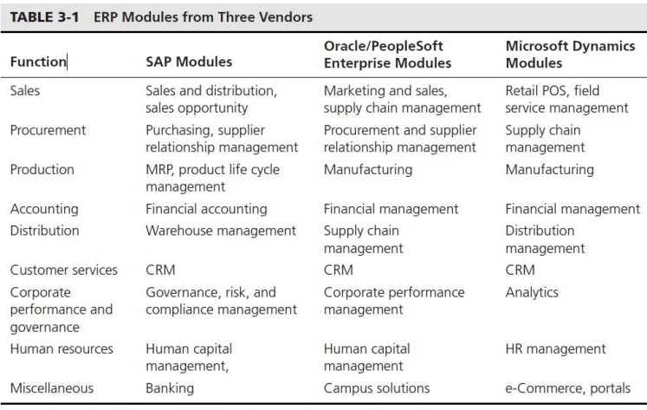

## implementation costs

* Unique business needs.
* The size and complexity of the business.
* Number of users.
* Customization required.
* hardware or hardware upgrade.
* Consultants and Analysts fees
* Time for implementation
* Training required

## Return of ERP Investment

* ERP eliminates redundant efforts and duplicated data; can generate savings in operations expense
* ERP help produce goods and services more quickly
* Company doesn’t implement an ERP system forced out of business by competitors
* save a company’s personnel, suppliers, distributors, and customers much frustration
* ERP systems provide real-time data

Using Return on investment (ROI)- Calculated by dividing the value of the project’s benefits by the project’s cost

## Why Companies Have More Success with ERP

Usually, low ROI are caused by people and misguided expectations, not computer malfunctions

* blindly hoping that new software will cure fundamental business problems
* not taking enough time for a proper analysis during planning and implementation phase
* skimping on employee education and training
* Companies not placing ownership or accountability for the implementation project on the personnel who will operate the system
* Unless a large project such as an ERP installation is promoted from the top down
* ERP implementation brings a tremendous amount of change for users

# W4

## Explain why unintegrated Marketing and Sales information systems lead to company-wide inefficiency and other problems

* Incorrect pricing
* Excessive calls to the customer for information
* Delays in processing orders
* Missed delivery dates
* Inefficiencies ordering process
  + Determining the delivery date
  + Checking customer’s credit status
  + Entering customer’s order into the current order entry system

### The Sales Process

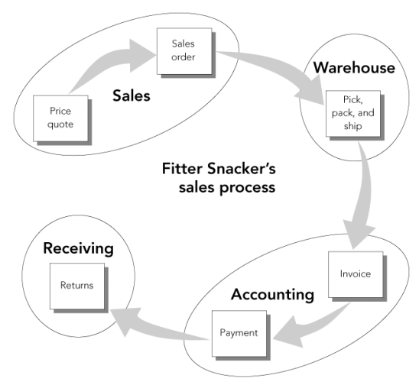

## Explain how integrated data sharing increases company-wide efficiency

process more accurate and efficient:

* ERP allows business processes to cut across functional area lines
* minimize data entry errors and provide accurate information in real time
* can track all transactions

Taking an Order in SAP ERP

* ERP system allows the user to group customers and salespeople
* Master data maintained in the central database and available to all ERP modules
* unique number is assigned to each customer
* determines whether data entered is valid
* Search

## Describe the sales and distribution process in the ERP system (eg SAP)

Client

* An independent environment in the system

Company Code

* Smallest org unit for which you can maintain a legal set of books
* Can have more than one sales organisation

Credit Control Area

* grants and monitors a credit limit for customers.
* It can include one or more company codes

Sales Organisation

* An organisational unit responsible for the sale of certain products or services.
* The responsibility of a sales organisation may include legal liability for products and customer claims
* A sales organisation is uniquely assigned to a company code.

Distribution Channel

* How products or services reach the customer
* Typical examples of distribution channels are wholesale, retail, or direct sales

Division

* A way of grouping materials, products, or services

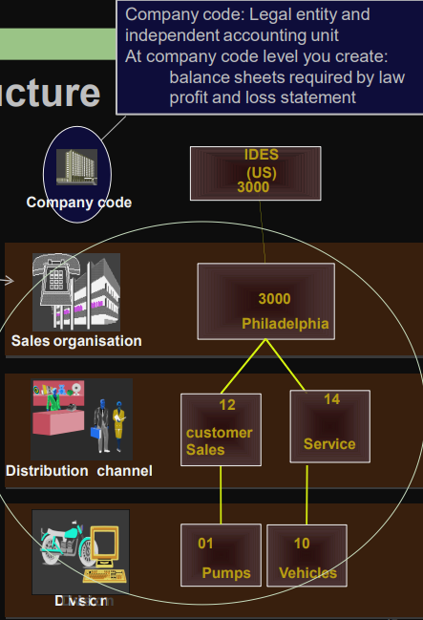

Sales Area

* Combination of Sales Organisation, Distribution Channel and Division
* Determines conditions (i.e. pricing) for sales activities

Plant (eg: Delivering Plant)

* Plant from which the goods should be delivered to the customer

Other SD organisation units:

* Shipping Point
* Loading Point
* Sales Office
* Sales Group
* Sales Person

## GBI Structure for Sales & Distribution

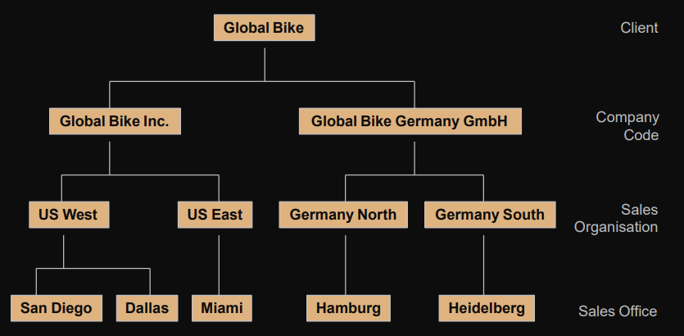

## Master data

### SD Master Data

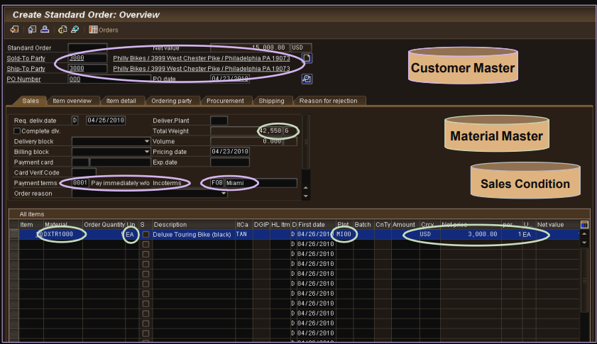

Data entry fields

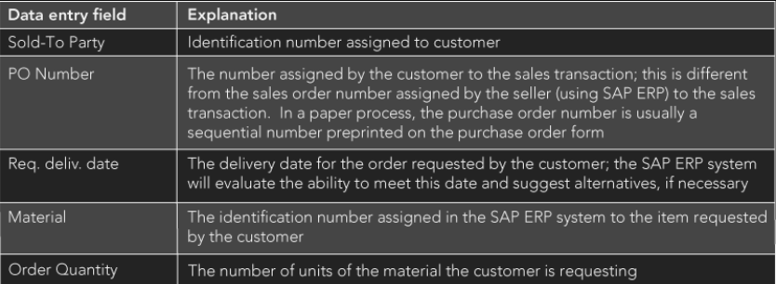

### Customer Master Data

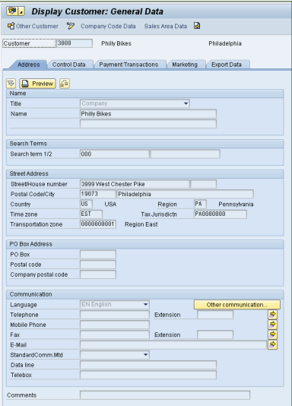

Customer Master

* Contains processing orders, deliveries, invoices and customer payment
* Every customer MUST have a master record

Created by Sales Area

* Sales Organisation
* Distribution Channel
* Division

The customer master information is divided into 3 areas:

* General Data
* Company Code Data
* Sales Area Data

### Material Master

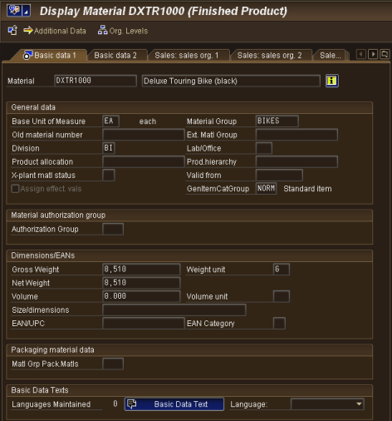

* manage about a material
* It is used by most components within the SAP system
  + Sales and Distribution
  + Materials Management
  + Production
  + Plant Maintenance
  + Accounting/Controlling
  + Quality Management
* Material master data is stored in functional segments called Views

### Condition Master Data (Pricing)

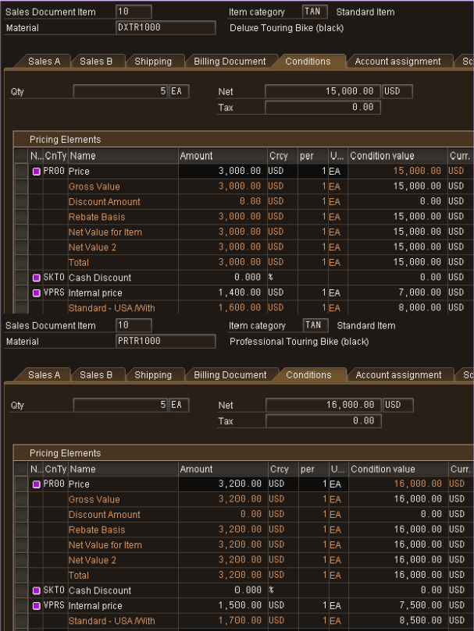

Condition master data includes:

* Prices
* Surcharges
* Discounts
* Freights
* Taxes

You can define the condition master to be dependent on various data:

* Material specific
* Customer specific

Conditions can be dependent on any document field

* Various kinds of discounts can be allowed
* system can enforce limits on the size of discounts

## Sales and Distribution in ERP

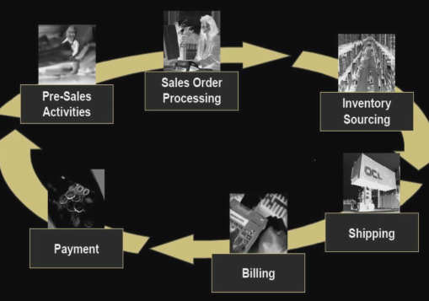

### Pre-Sales Activities

Sales Support assists in the sales, distribution, and marketing of a company’s products and services to its customers

– Creating and tracking customer contacts and communications

* Phone call records
* On-site meeting
* Letters
* Campaign communication

– Implementing and tracking direct mailing, internet, and trade fair campaigns based on customer attributes

Pre-sales documents need to be managed within the presale’s activities: Inquiries and Quotations. These documents help identify possible sales related activity and determine sales probability.

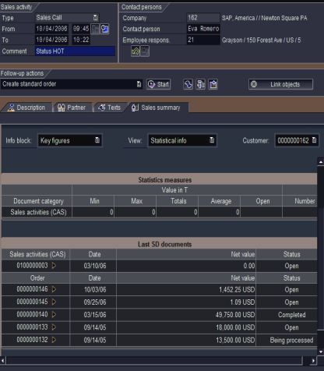

ultimate goal is to equip the sales technician with all the information necessary to negotiate and complete the potential sale

#### Inquiry

customer’s request to a company for information or quotation in respect to their products or services without obligation to purchase

* How much will it cost
* Material/Service availability
* May contain specific quantities and dates

The inquiry is maintained in the system and a quotation is created to address questions for the potential customer

#### Quotation

presents the customer with a legally binding offer to deliver specific products or a selection of a certain number of products in a specified timeframe at a pre-defined price.

#### Creating a Sales order

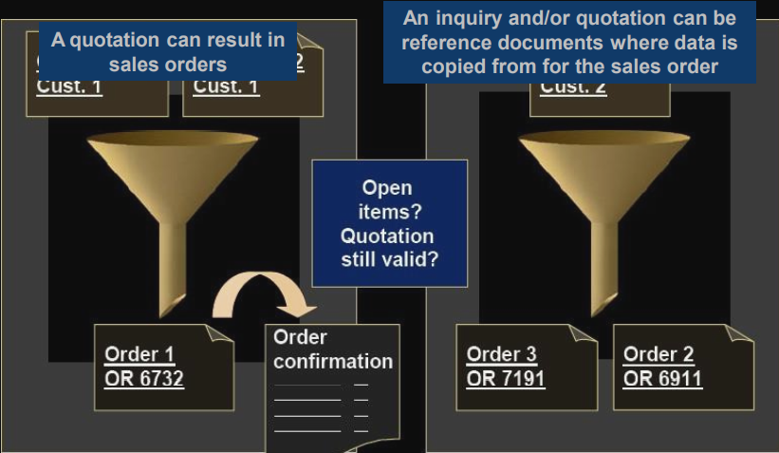

### Sales Order Processing

* series of activities that must take place to record a sales order
* can start from a quotation or inquiry or just a call-in from customers
* Information collected from the customer to support the quotation is immediately included in sales order
* Steps:
  + Recording the items to be purchased
  + Determining the selling price
  + Recording the order quantities
* Users can define various pricing alternatives in the SAP ERP system
* SAP ERP system checks the Accounts Receivable tables in the SAP ERP database to confirm the customer’s available credit
* If customer has sufficient credit available
  + Order is completed
* If customer does not have sufficient credit available
  + ERP system prompts sales personnel to take one of the possible appropriate actions

#### Sales Order

– Header

* Data relevant for the entire sales order: Ex: customer data, total cost of the order

– Line Item(s)

* Information about the specific product: Ex: material and quantity, cost of an individual line

– Schedule Line(s)

* Uniquely belongs to a Line Item, contains delivery quantities and dates for partial deliveries

contains all of the information needed to process your customer’s request:

* Delivering Schedule
* Shipping point and route determination
* Availability Check
* Transfer of requirements to MRP
* Pricing
* Credit limit check

#### Delivery Scheduling

* When an order is created you must enter a requested delivery date for the order or each line item.
* system will then determine a delivery timeline, this will be used when determining our material availability, or ATP (Availability to Promise) date
* system will determine this date using forward and backward scheduling rules you have defined

#### Backward Scheduling

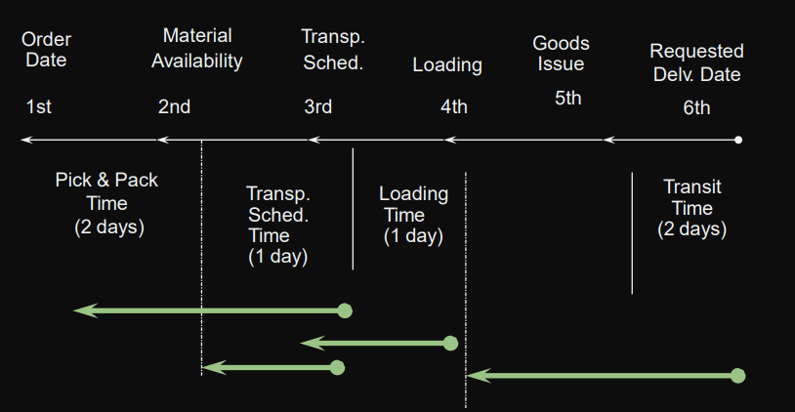

#### Forward Scheduling

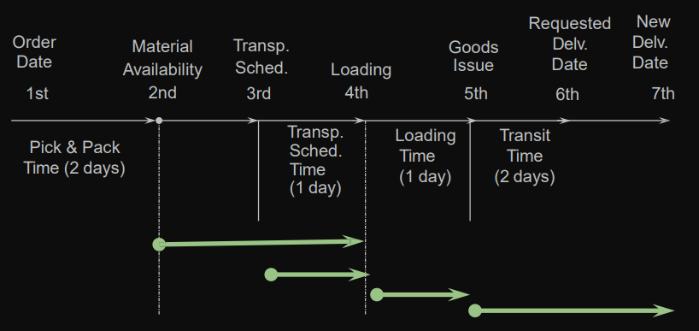

#### Shipping & Route Determination

* system must determine the shipping point from which the material will be shipped and the route the material will take to get from your warehouse to your customers location
* shipping point is determined for each line item within the order
* route determination is used to define the transit time of the material that we used in scheduling

#### Pricing

* system displays pricing information for all sales documents on the pricing screens at both the header and the line-item level
  + Header pricing is valid for the whole order it is the cumulative of all line items within the order
  + Line-item pricing is for each specific material.
* The system will automatically search for price, discounts, surcharges, calculate taxes and freight. You can manually manipulate the pricing at both the header and line-item level within the sales order by entering a condition type and amount
  + Taxes and freight can be calculated automatically

#### Credit Check

* Allows company to manage its credit exposure and risk for each customer by specifying credit limits
* During the sales order process the system will alert the sales rep about the customer’s credit situation that arises, if necessary, the system can be configured to block orders and deliveries

### Inventory Sourcing

* Available-to-Promise (ATP) check
  + checks company’s inventory records and production planning records
    - Requested material is available
    - Requested material can be delivered on the date
  + Includes expected shipping time

#### Availability Check

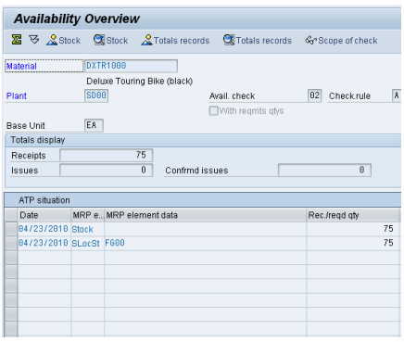

* Availability Check
  + – Determines the material availability date
  + – Considers all inward and outward inventory movements
* 3 methods of delivery
  + – One-time delivery
  + – Complete delivery
  + – Delayed proposal

### Delivery (Shipping)

* shipping process begins when the delivery document for the sales order is created
  + – Picking
    - 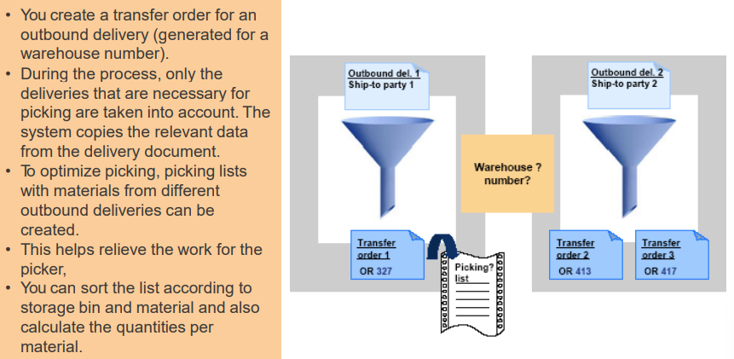
  + – Packing
    - 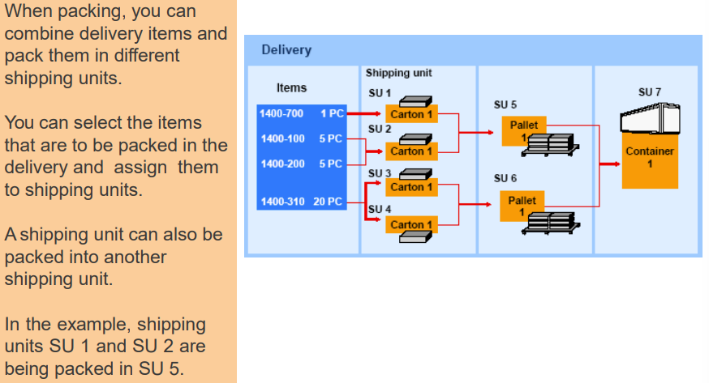
  + – Post Goods Issue
    - Event that indicates the legal change in ownership of the products
    - Reduces inventory and enters Cost of Goods Sold
    - Automatically updates the General Ledger (G/L) accounts
    - Ends the shipping process and updates the status of the shipping documents
* Integrate with the Material Management (MM) and Finance (FI)
* Delivery process allows deliveries to be created so that the warehouse and shipping activities are carried out efficiently
* Once the system has created documents for picking, packing and shipping, documents are transferred to Materials Management module

### Billing

* The billing document is created
  + The sales order (Order-based billing), and/or
  + The delivery document (Delivery-based billing)
* used to generate customer invoice which can be mailed, faxed, or transmitted electronically to the customer
* It will update the customer’s credit status.
* document will automatically create a debit posting to your customer and credit your revenue account
* passed over to Financial Accounting to await payment

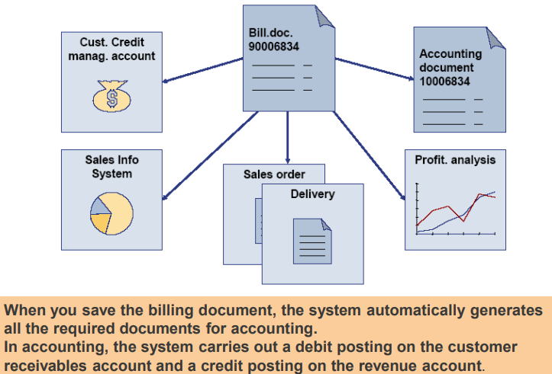

### Payment

* Payment is the final step is managed by the Financial Accounting department
* Includes
  + Posting payments against invoices
  + Reconciling differences between payment and invoice
* Payment will create a posting clearing the liability
  + Debits cash (Bank Account) and credits (reduces) customer’s account
* Timely recording of this transaction affects the timeliness and accuracy of any subsequent credit checks for the customer

### End to End Processes

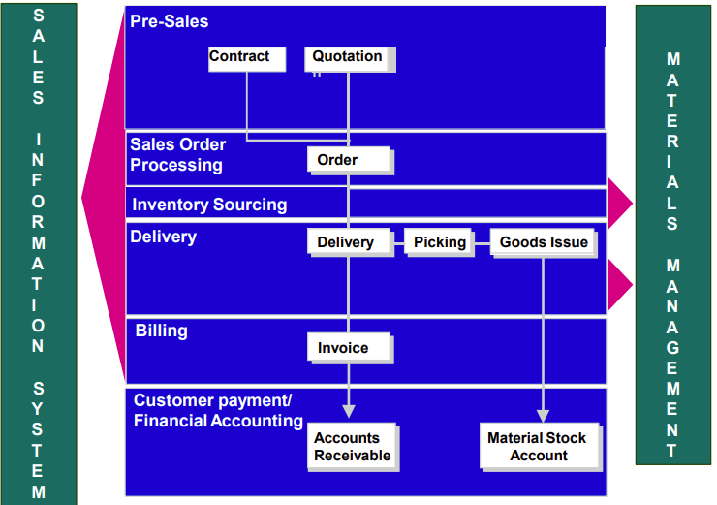

## Customer Relationship Management

help companies streamline their interactions with customers

### SAP’s CRM Software

* processes business transactions and provides much of the raw data for CRM
* system for reporting and analysis of transactional data
* Advanced Planner and Optimizer (APO): system that supports planning of the supply chain

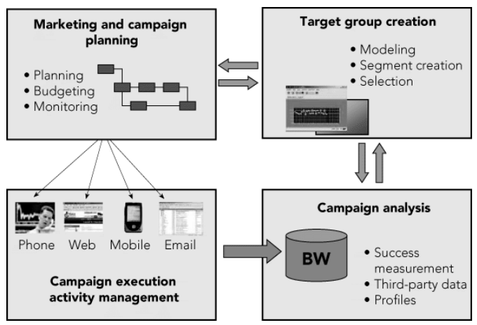

### Core CRM Activities

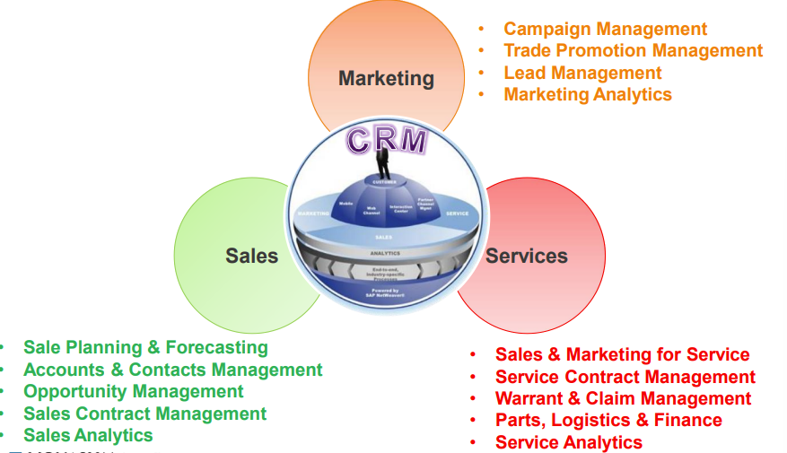

Benefits

* Lower costs
* Higher revenue
* Improved strategy and performance measurement

# W5

## Production Overview

* To meet customer demand efficiently
  + Develop a forecast of customer demand
  + Develop a production schedule to meet demand
* Goal of production planning is to schedule production economically
* Three general approaches：
  + Make-to-stock: made for inventory
  + Make-to-order items: produced to fill specific customer orders
  + Assemble-to-order items: produced using a combination of make-to-stock and make-to-order processes

## Production Problems without ERP

Communication problems

* Marketing and Sales do not share information Production
* Production hard to deal with increases in demand >> Might cause shortages or stockout

Inventory problems

* Production manager lacks systematic method for:
  + Meeting anticipated sales demand
  + Adjusting production to reflect actual sales

Accounting and purchasing problems

* Standard costs: normal costs of manufacturing a product
* Production and Accounting must periodically compare standard costs with actual costs and then adjust the accounts for the inevitable differences

## The Production Planning Process

### Sales Forecast

Work from sales forecast and current inventory levels to create an “aggregate” (“combined”) production plan for all products

### Production Plan

Break down aggregate plan into more specific production plans for individual products and smaller time interval

### Raw Material Requirements

Use production plan to determine raw material requirements

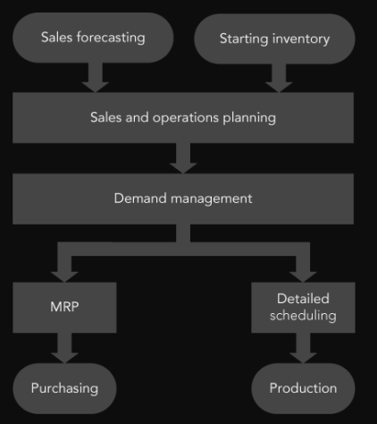

## Sales Forecasting

* Use a prior period’s sales and then adjust those figures for current conditions
* In ERP, sales forecast can be made using
  + Historical sales data
  + from plans developed in Controlling (CO) module
    - Profit goals for company can be set
    - Sales levels needed to meet the profit goals can be estimated

### Sales and Operations Planning (SOP)

* Input: sales forecast provided by Marketing
* Output: production plan
  + Production plan is the input to the next step, demand management
* Rough-cut planning: common term in manufacturing for aggregate planning
  + Disaggregated to detailed production schedules
  + Rough-cut capacity planning applies simple capacity-estimating techniques to the production plan to see if the techniques are feasible
* Disaggregating the sales and operations plan

## Demand Management

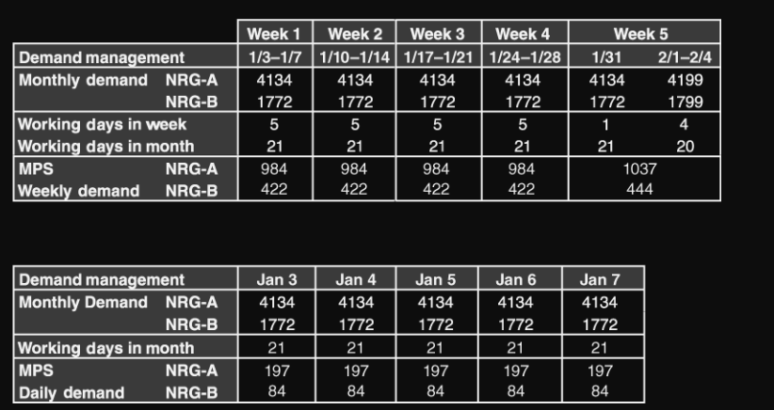

* creates a forecast of demand. Forecast is based on customer contracts, planned sales orders
* Output: master production schedule (MPS)
* Planned independent requirements are warehouse requirements.
  + initiate the purchase of materials without waiting for sales orders
* Process:
  + Past sales order form forecasting
  + One off events such as trade fairs can be included
  + 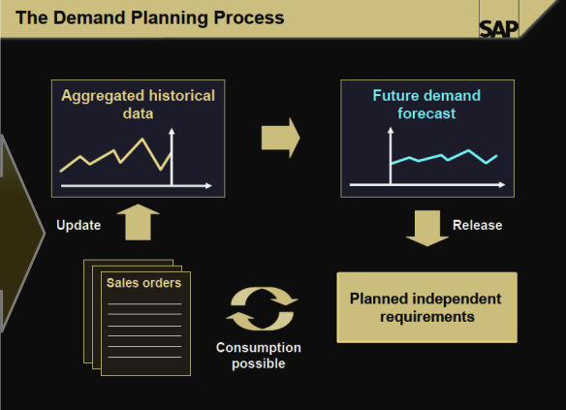

## Materials Requirements Planning (MRP)

* Determines required quantity and timing of the production or purchase of subassemblies and raw materials needed to support MPS
* Bill of material (BOM): list of the materials needed to make a product
* Lead times and lot sizing
  + Lead time: cumulative time required for the supplier to receive till deliver item to the manufacturer
  + Lot sizing: determining production quantities and order quantities

### In SAP ERP

* The main purposes:
  + Plan the capacity
  + Assign the correct priorities to items
  + Control inventory levels
* Stock/Requirements List shows:
  + – Planned orders
  + – Purchase requisitions (PurRqs)
  + – Purchase orders (POitem)
* Planner can convert a planned order to a purchase order from Stock/Requirements
* Integrated system allows Purchasing to make the best decision on a vendor based on information

### MRP system inputs/outputs

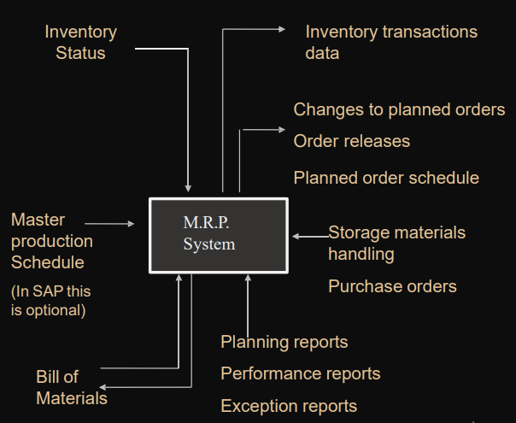

* major inputs:
  + Inventory status: Stock of materials used in production. It is updated as stock is received from vendors and as stock is sent out to manufacture the final product
  + MPS: Provides a diary showing which jobs will be done, the order in which they will be done, which work group or machine will do the work and when each job should start and end.
  + BOM: Is a listing of all components, including partially assembled pieces and basic parts that make up an end product

## Providing Production Data to Accounting

* ERP packages do not directly connect with production machines
* Data can be entered by a barcode reader

## ERP and Suppliers

* Working with suppliers collaboratively requires trust among all parties
  + Company opens its records to its suppliers
  + Suppliers can read company’s data because of common data formats
* Advantages
  + Reductions in paperwork
  + Savings in time

## The Traditional Supply Chain

* EDI and ERP
  + companies could be linked with customers and suppliers through electronic data interchange (EDI) systems
* ERP system can facilitate SCM
  + Needed production planning and purchasing systems already in place
* With ERP system, sharing production plans along the supply chain can occur in real time

## Supply Chain Management

* Traditionally SCM was not part of ERP because SCM link the company with external partners, whereas the focus of ERP was on the internal functions
* ERP system include CRM and SCM that provide an efficient and flexible environment between the company and business partners, suppliers, distributors, customers
* SCM provides a link for services, materials, and information across the value chain of the organisation. They may include procurement, outsourcing, manufacturing flow management, order fulfilment, forecasting, etc.
* The SCM strategy must be aligned with the corporate strategy of the organization.
* A strong SCM implementation is necessary for e-Business

## The Measures of Success

* Performance measurements
  + Metrics
  + Show the effects of better supply chain management
* Cash-to-cash cycle time
  + Time between paying for raw materials and collecting cash from customer
* SCM costs
  + Include cost of buying and handling inventory, processing orders, and information systems support
* Initial fill rate
  + Percentage of the order that the supplier provided in the first shipment
* Initial order lead time
  + Time needed for the supplier to fill the order
* On-time performance
  + If supplier agreed to requested delivery dates, tracks how often supplier met those dates

# W6

## Accounting Activities

Areas of accounting:

* Financial accounting
* Managerial accounting

Financial accounting

* Documenting all transactions of a company

the financial state of the firm

* Using documented transactions to create reports for external parties and agencies
* Reports, or financial statements, must follow prescribed rules and guidelines of various agencies

Managerial accounting

* determining costs and profitability of company’s activities

## Financial Accounting

Common financial activities and statements

* Ensure accounts accurate and up-to-date
* Making “Closing” entries and “Adjusting” entries
* 2 Common financial reports: Balance sheets and Income statements

Balance sheet

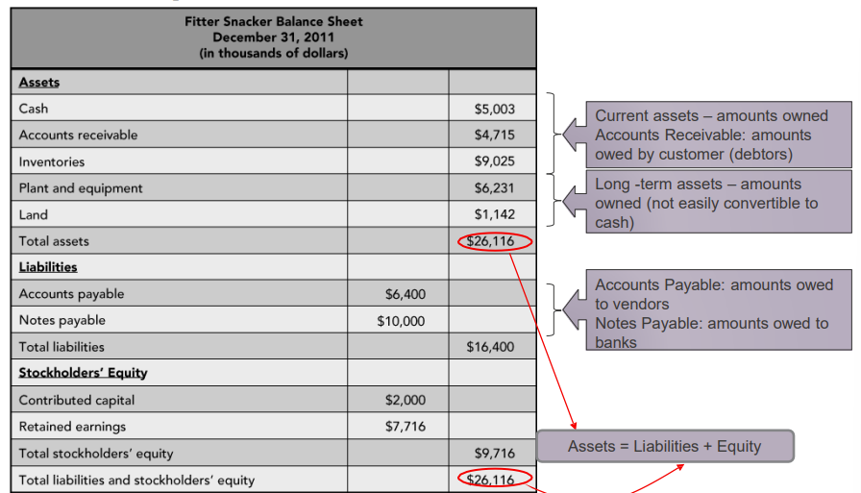

* Statement that shows account balances
* Assets = Liabilities + Equity
  + Current assets: Cash, Inventory,
  + Long-term assets such as Building, Equipment, Land
* Liabilities: Amounts owed to vendors, banks, and other creditors
* Equity: Amounts owners have invested in company

Income statement

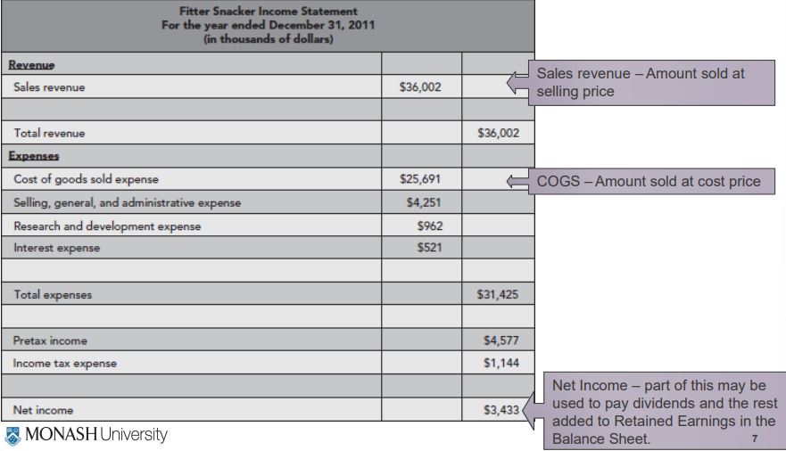

* Profit and loss (P&L) statement
* Shows company’s sales, cost of sales, and profit or loss

### Financial Transparency

* ERP systems provide the ability to drill down from a report to the source documents (transactions) that created it
  + Makes it easier for auditors to confirm the integrity of reports
* With a properly configured and managed ERP system, there are direct links between the company’s financial statements and individual transactions that make up the statements
  + Fraud and abuse can be detected more easily

## Managerial Accounting

Determine costs and profitability of company’s activities

* To develop long-term plans and strategy Provide managers with detailed information
* To make informed decisions
* To create budgets
* To determine profitability

Information that managers use to control day-to-day activities

* To develop operational plans
* To handle different managerial issues

## Inventory Cost Accounting

Manufactured item’s cost has three elements:

* Cost of raw materials
* Cost of labor
* other costs

Direct costs: materials and labor

* Can be estimated

Indirect costs: overhead items

* Difficult to associate with specific product(s)

Standard costs for a product are established by:

* Studying historical direct and indirect cost patterns
* Taking into account the effects of current manufacturing changes
* Cost variances: differences between actual costs and standard costs

### Inaccurate Inventory Costing Systems

Calculating inventory costs

ERP and inventory cost accounting

* Many companies with unintegrated accounting systems analyze their cost variances infrequently
* Often, do not know costs of a product
* With an ERP system, employees throughout the company would have recorded costs in a company-wide database as they occurred
* ERP system configurations allow analysts to track costs using many bases

ERP and Activity-based costing

* Accountants identify activities associated with overhead cost generation and then keep records on costs and activities
* ABC requires more bookkeeping than traditional costing methods

## Unintegrated vs Integrated systems

### Unintegrated

* Data sharing did not in real time
* Accounting data were out of date
* Accounting personnel had to do significant research
* •company’s accounts are kept in a record called a general ledger

### Integrated

* ERP system, with its centralized database, avoids these problems
* Simplifies process of closing books and preparing financial statements
* In the SAP ERP system, different modules (such as SD, MM, PP, HR, AM) cause transaction data to be entered into the general ledger simultaneously as and when the business transactions occur

## Management Reporting with ERP Systems

* Generating the right reports for the right situation is often challenging
* Without an ERP system, the job of tracking is hard
* With ERP system, great amount of information is available for reporting

### Document Flow

* With an ERP system, all transactions in all areas of a company get posted in a centralized database
* Each transaction posted in SAP ERP gets its unique document number
  + Allows quick access to the data
* In SAP ERP, document numbers for related transactions are associated in the database
  + Provides an electronic audit trail

### Built-In Analysis Tools

Maintenance of Accounting records

* Accounting records maintained in the common database

Advantage of using an integrated database

* Provides the ability to query the records to:
* Produce standard reports
* Answer ad hoc questions

Data Warehouse

* SAP provides a data warehouse within each major module
* Data warehouse: repository for data from various sources

## Trends in financial reporting

* XBRL
* XML
* ERP systems accept data in XML and XBRL into database

# W7

## Business Process

### Improvement/Optimisation/Re-engineering

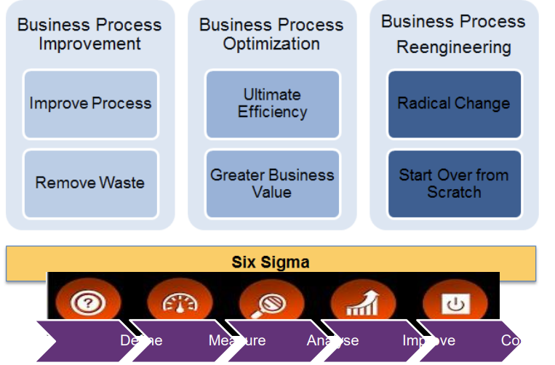

## Business Process Re-engineering

BPR is the analysis and redesign of workflows between enterprises to optimize end-to-end processes and automate non-value-added tasks

#### Methodology

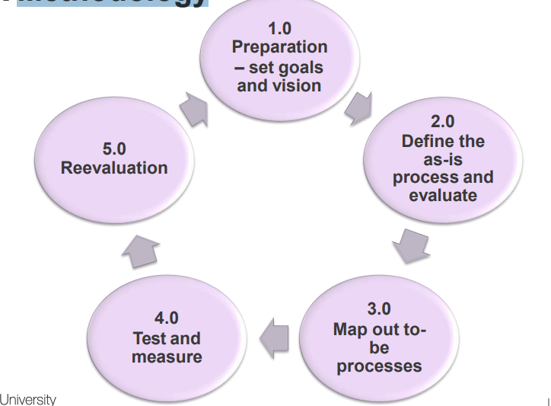

#### Process Modeling

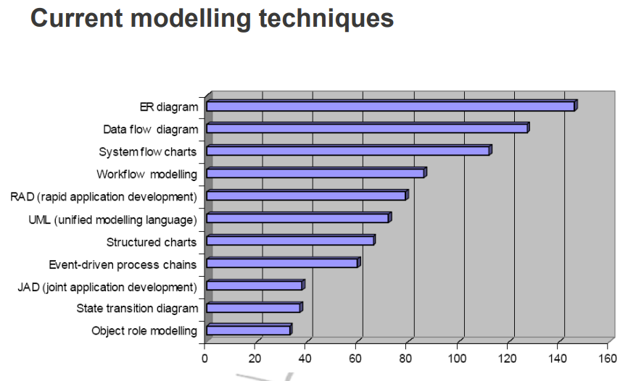

* Tools: describe a business process so that can understand the process
* Process model: any abstract representation of a process
* Advantages:
  + Graphical representations easy to understand
  + good starting point for analyzing a process
  + Participants can design and implement improvements
  + Document the business process
  + Easier to train employees to support the business process

### Flowcharting

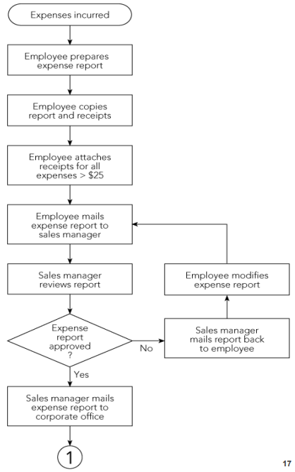

* Any graphical representation of the movement or flow of concrete or abstract items
* Clear, graphical representation of a process from beginning to end
* Uses a standardized set of symbols
* Hierarchical modelling

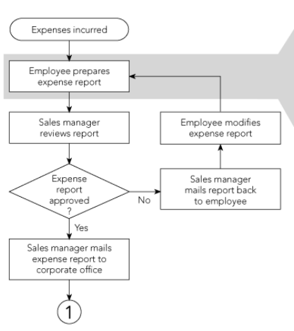

* Deployment flowcharting

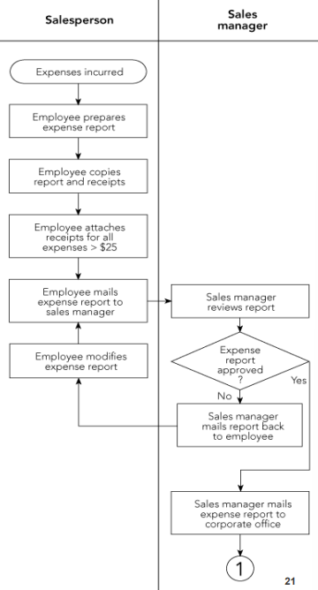

### Event Process Chain (EPC)

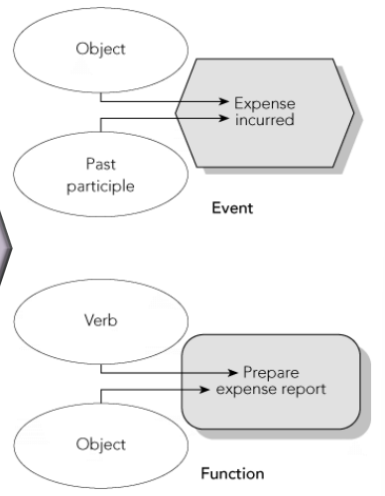

* Enforces an event-function-event structure
* Uses only two symbols to represent a business process
* Matches the logic and structure of SAP’s ERP software design
* Two structures: events and functions
  + Events: a state or status in the process
  + Functions: part of the process where change occurs

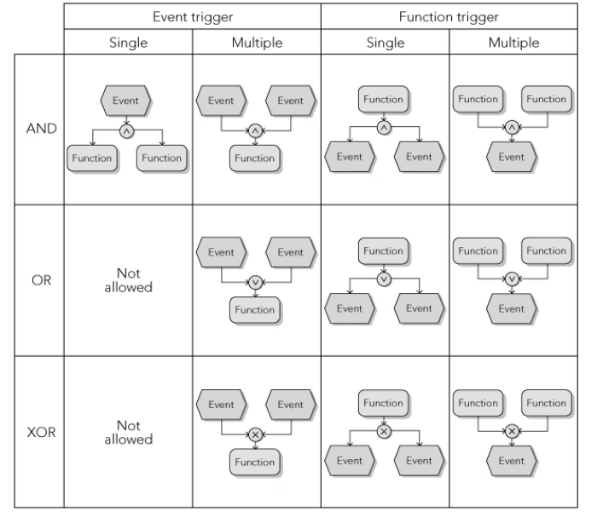

Splitting and consolidating paths

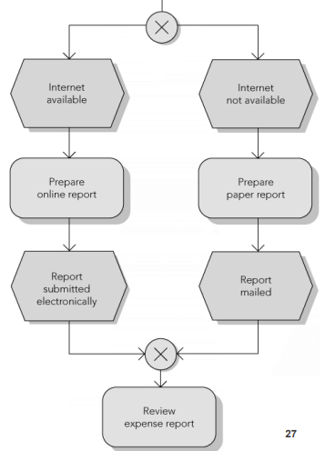

with organizational and data elements

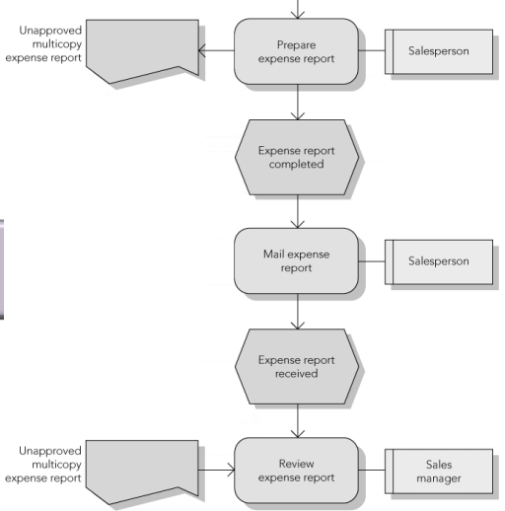

## Process Improvement

### Value analysis

* Each activity in the process is analyzed for the value it adds to the product or service
* Value added is determined from the perspective of customer
* Real value: value for which the customer is willing to pay
* Business value: value that helps the company run its business
* No value: an activity that should be eliminate

### Evaluating

* Disrupting the current process to make changes can be costly and time consuming
* Dynamic process modeling takes a basic process flowchart and puts it into motion
  + Uses computer simulation techniques to facilitate the evaluation of proposed process changes
* Computer simulation
  + Uses repeated generation of random variables that interact with a logical model of the process
  + Predict performance of the actual system

## ERP Workflow Tools

* Software automates the execution of business processes and address all aspects of a process, including:
  + Process flow (logical steps in the business process)
  + People (the organization)
  + Effects (the process information)
* ERP provides a workflow management system
  + Supports and speeds up business processes
  + employees carry out complex business processes and track the current status
* Features and Benefits
  + Links employees to the business transactions
  + Employees can track and monitor progress of workflow and take action if task is behind schedule
  + Internal email and workflow tasks connect employees to business transactions
  + Workflow system can automatically take various actions like:
    - Changing task priority
    - Sending email reminders to the employees
  + workflow tools improve process efficiency and effectiveness

# W8

## ERP Implementation Life cycle

* Like SDLC (system development life cycle)
* Approaches
  + Traditional ERP development life cycle

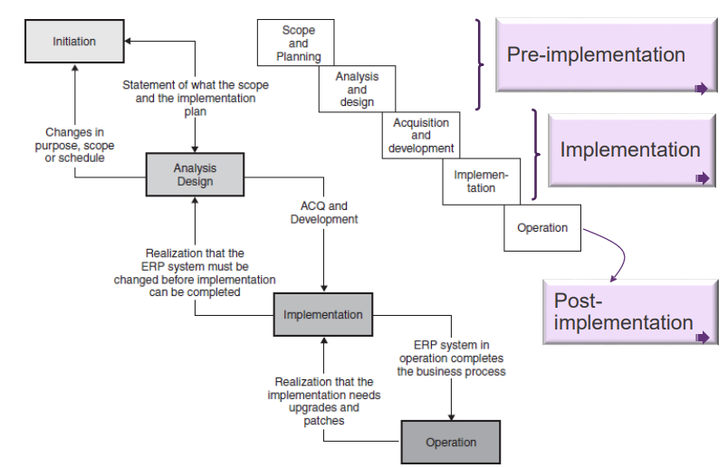

* + Rapid ERP life cycles
    - Total Solution,
    - FastTrack,
    - Rapid-Re,
    - Accelerated SAP (ASAP)
      * – Phase 1: Project preparation
      * – Phase 2: Business blueprint
      * – Phase 3: Realization
      * – Phase 4: Final preparation
      * – Phase 5: Go-live and support
    - Business integration methodology (BIM)

## Pre-implementation

### 1. Identify success factors and potential risks

* Develop a business case
* Determine the scope, system needs
* Identify potential risks and gaps

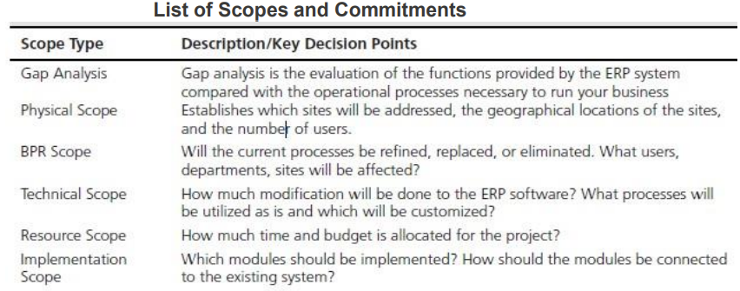

### 2. Determine implementation, integration and resource strategies

* Identify the system functionality, modules, and integrations prior
* Ensure there is time built into the project for testing and training.
* Plan for a realistic and achievable timeline.
* Maintain some “workaround” to keep the transition manageable
* Identify which systems/applications are a must-have on go-live
* ERP conversion strategy – Phased vs big bang approach or hybrid?

### 3. Define the process, organisational and infrastructure changes

* Develop and update standard operating procedures (SOP’s)
* Align with industry standards and leverage best practice processes
  + identify processes outside of best practice
  + May require configuration/customization efforts; or
  + Be prepared to change processes
* Organisational changes
  + determining a new org structure that supports new roles and responsibilities
* Physical and network infrastructure changes
  + Identify potential to align and organise the system infrastructure,
  + Breaking down siloes and defining the new structure before the new system is implemented

### 4. Focus on data governance

* “Garbage in, garbage out.”
  + The company should complete at least one thorough round of data cleansing before data migration.
  + Determine what is master data and reduce redundant entries.
* New systems would most likely have advanced data analytics or predictive analytics capabilities.
* To perform extensive data analysis, data needs to be captured and classified properly.
* Important to spend time classifying data groups for future reporting

### 5. Determine future KPIs and reporting needs

* Define which key metrics are needed before implementation
* Which standard reports will you be utilizing?
* Which custom reports will need to be designed?
* Determine the fields required to capture usable data for analytics and reporting.
* Create pre-project and post-project metrics to track.
* Creating benchmarks for all departments to gauge the success of the project.

### 6. Address organisational change management on the front-end

* start communicating with employees and stakeholders.
* resistance to change and gaining end user adoption of a new system or new process is crucial
* Organizational change starts from the top
  + Executives have buy-in for the project and need support
  + Leaders, subject matter experts and employees should be working on the implementation team.
  + Crucial to take time to form a strong implementation team

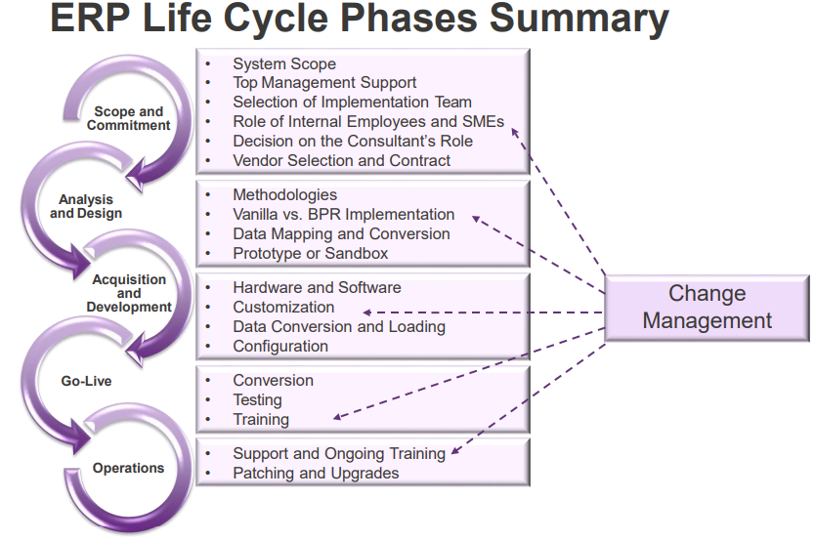

### 7. Leverage the expertise of an independent consulting firm

* Selecting ERP requires the unbiased advice
* An ERP consulting firm has the expertise necessary to guide an organization through unbiased software selection
* An ERP consulting firm has no association with specific vendors, no potential conflicts of interest would act in the best of the client.
* No ERP system, no matter how advanced, automatically fixes inefficient business processes. This is why many independent consultants emphasize the importance of focusing on business process reengineering and organizational change management before software selection.

## Approaches

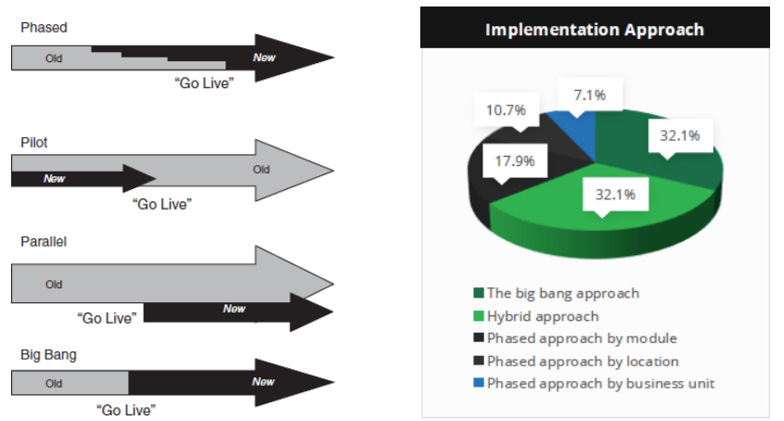

## ERP Failures

* Lack of purpose for implementing ERP
* Not going into the project with the ‘eyes wide open’
* Lack of executive and management buy-in
* Not leveraging the “A-Team” from the business
* Not choosing software that is aligned with the business and key requirements
* Misalignment between software configuration and business processes/workflows
* Lack of effective OCM and training
* Weak internal and external project management
* Underdeveloped business case to manage business benefits

## Budget Overruns

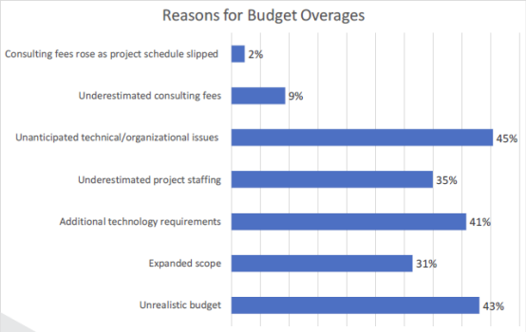 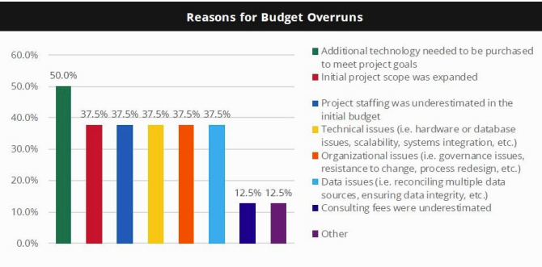

## Duration Overruns

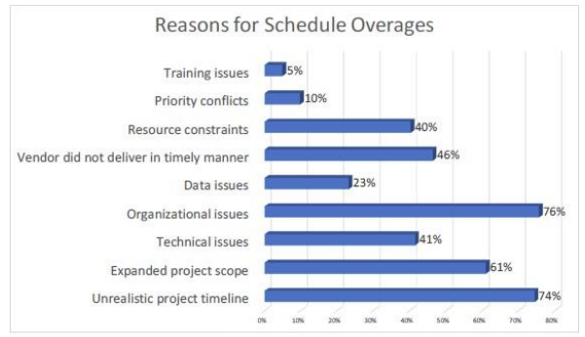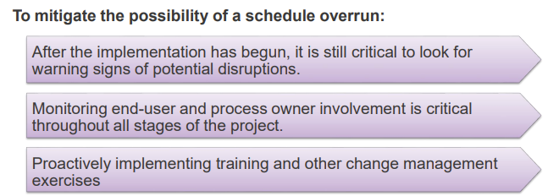

## Schedule Overages

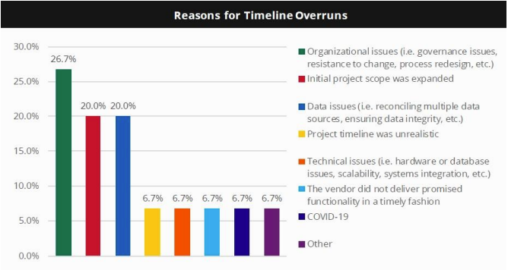

## 5 keys to successful ERP Implementation

* Clear alignment with overall business strategy
* Realistic expectations during planning
* Laser focus on people, organisational change management and workforce transition
* Effective business process management and process improvement
* Strong project management, governance and controls

### Successful Project

Projects:

* Deliver functionality & usability to users
* Achieve business and strategic goals
* Realise financial benefits
* Satisfy business stakeholders

Project management:

* Completes project within budget, on time and within scope
* Provides project with appropriate quality standards and scope (PMBOK)

# W9

## Warning sign Implementation:

* Not reviewing the project with the team on at least bi-monthly basis
* There is no dedicated project team.
* There is no training scheduled until less than 90 days before golive.
* The organisational change management plan only consists of end-user training.
* No contingency budget.
* Don’t have at least three iterations of conference room pilots or integration testing.
* Budget assumes that software license costs are a majority of the total implementation costs.
* Don’t have a strong program management team
* The software techies are running the project
* Don’t have a business case, performance metrics, or a benefits realisation plan.
* little margin for error to miss customer shipments at go-live.
* Will not customise the software, under any circumstances.

## Project Risks

### Risks and Risk Management

* Risks are the consequences of uncertainty
* Project risks = Event * probability of the event occurring *consequences of the event
* Risk is a combination of the probability of a negative event occurring and its consequences

#### Risks

* Generically, a risk is “the possibility of loss or injury”
* project risk is an uncertainty that can have a negative or positive effect on project objectives
* In an IT project a negative risk is any event that may bad objectives of the project.
* Positive risks are opportunities
* The goal is to minimise negative risks while maximising positive risks
* Risks need to be identified and managed

#### Risk Management

* understanding and managing the risks
* Risk management is an investment—costs are associated with it.
* Cost for risk management should not exceed the potential benefits
* Risk management should be ongoing and pro-active.
* Risk management has transformed from a ‘department focused’ approach to a holistic, coordinated and integrated process which manages risk throughout the organisation.
* Enterprise Risk Management is the term given to the alignment of risk management with business strategy and the embedding of a risk management culture into business operations

#### Enterprise Risk Management (ERM)

* Enhanced decision-making by integrating risks
* The resultant improvement in investor confidence and hence shareholder value
* Focus of management attention on the most significant risks
* A common language of risk management which is understood throughout the organisation
* Reduced cost of finance through effective management of risk

## Risk Management Process

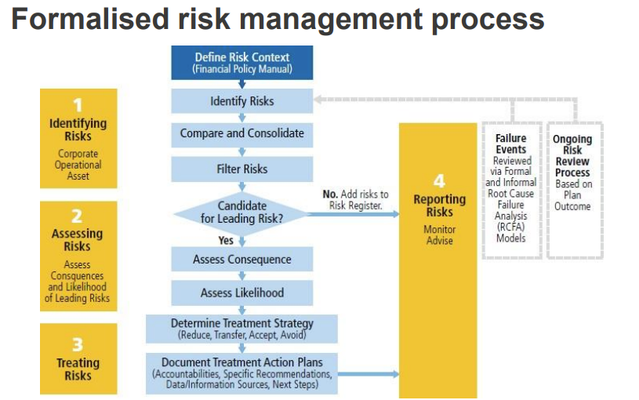

### 1. Risk Identification

* Based on previous (historical) experience with similar projects
* Develop a list of risk factors and weight according to their potential impact
* Highest risk is at the outset of the project
* tools and techniques
  + – Brainstorming – The Delphi Technique – Interviewing – SWOT analysis

#### Risk Register

* – A document that contains the results of risk management processes often presented in a table
* – A tool for documenting risk events and related information

### 2. Risk Assessment

* The analysis and evaluation of risk through the process of identification, description and estimation to assess their potential consequences
* Risk assessment is the most difficult phase
* Risk is based on uncertainty and constraint of the project requirements
  + Uncertainty – politics
  + Triple constraints (Cost, Time and Scope)
* Some constraints will be difficult to evaluate and remove
  + Culture
  + Work team environment
  + Manpower
  + Availability of skilled staff

### 3. Risk Response

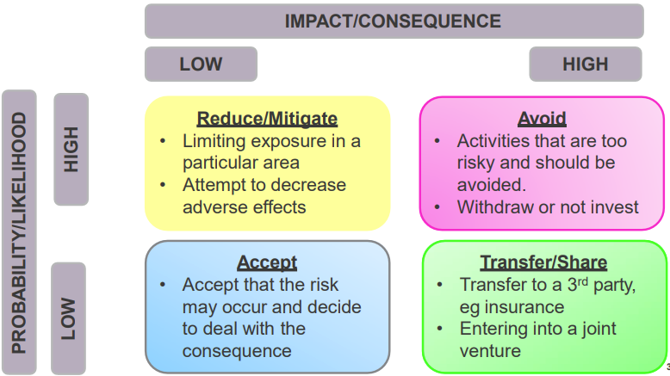

* Plan responses to minimise the impact/probability of the risks
* Contingency plans
* Exposure to severe risks is minimised
* Unnecessary risks are avoided
* Appropriate measures of control are taken
* The balance between risk and return is appropriate
* Negative
  + Transference/Sharing
  + Avoidance
  + Reduction/mitigation
  + Acceptance
* Positive Risk
  + Sharing
  + Exploitation
  + Enhancement
  + Acceptance

### 4. Risk Monitoring/Control

* Monitor how well the risks are mitigated and managed
* Adopt appropriate tools
* This should be an iterative process
* Owners should be assigned to major risks for monitoring
* Risk control is conducted for all risks categorised as a high-risk high consequence (Medium risks are analysed separately)

# W10

## Systems Integration

* linking computing systems and software applications physically or functionally, to act as a coordinated whole
* involves
  + Systems testing to verify that the system meets its requirement
  + Validating that the system performs customer/user expectation

### Master data

implies all application users within the company link to a single core repository of the data

#### Master Data Management

##### is

* set of disciplines, processes and technologies
* used to create and maintain
  + consistent,
  + complete,
  + contextual and
  + accurate data quality
* of multiple domains of enterprise master data across applications, systems and databases.
* Ensures quality business data for all stakeholders (users, and applications) across and beyond the enterprise landscape
* Move to a single version of the truth about business objects

##### main drivers

* Regulatory compliance and reporting
  + Sarbanes Oxley
* Partner integration and collaboration
* Global demand and supply chain optimisation
* Privacy and data protection
* Meaningful data mining
  + Improved customer insight and interactions
* Better able to manage data
* Data integration to enable BI (Business Intelligence)

##### Without

* No MDM - No one consistent view of data – every department has different data
* Master data generated and trapped in silos
* Inaccurate information
* Incomplete view

### Business Intelligence

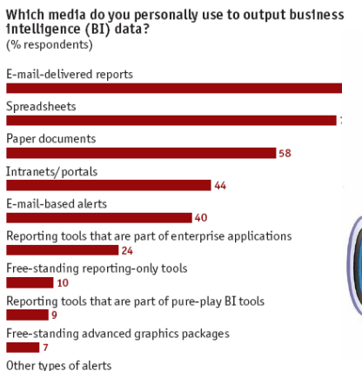

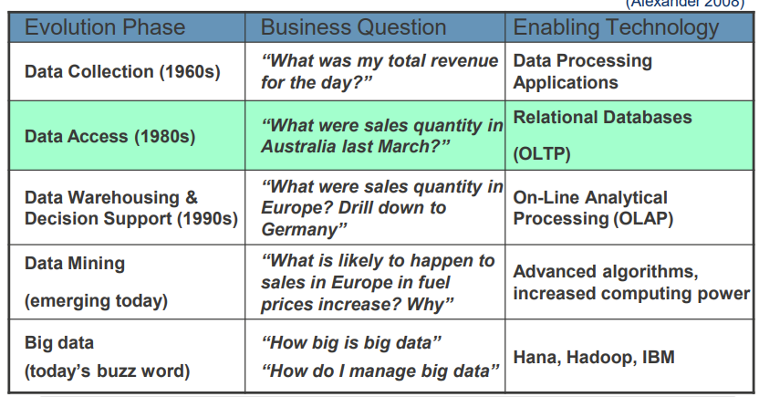

## Change Management

### summation of responses

* Keeping staff informed by communicating changes and the need for these changes
* Training staff
* Using staff as expert users and trainers
* staff could relate to them – Train the trainer approach
* Training manuals which are easy to follow
* Users of the system form part of the process
* Employ a variety of change strategies

### Key Training Issues

* Identify strategies to manage stakeholders
  + Needs analysis /deskilling /up-skilling
  + appropriate trainers and training with appropriate documentation with ongoing support
* Standardised training
  + Consultant attribute – Transfer of knowledge/Train the trainer
  + Trainer attributes
* Training needs analysis
  + Identify training needs based on the business process changes to them
  + job role and the amount of contact with the new system
  + Identify stakeholder requirements
  + analyse prospective attitude issues that could negatively impact on the implementation
* Post implementation review based on business case outcomes (timings and expectations)

### Key points to note when managing change

* keep explaining why we are changing
* involve your team in decision making
* minimize uncertainty
* engage your legacy system & process experts early
* be as transparent
* create learning opportunities for your team
* communicate the threat of not changing
* keep listening to your people’s concerns
* celebrate shifts towards the desired state

### people react

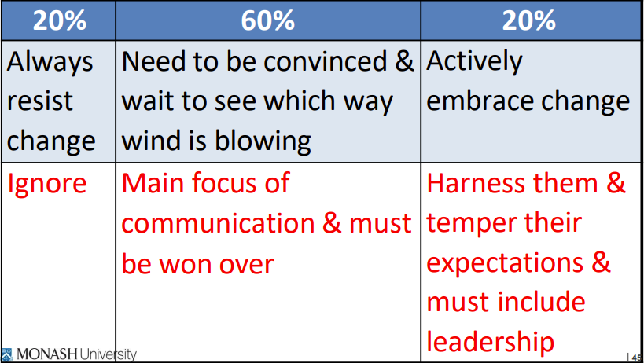 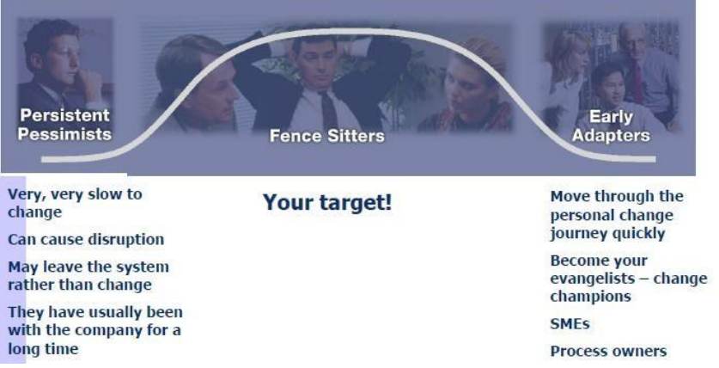

### Best Practices

* Customise training and communications
  + Communications and training should be immediately applicable to your organisation’s specific situation
* Assess change readiness
  + Measure and identify the root causes for organisational resistance.
  + Having a series of online surveys and focus groups to gauge employee acceptance and other organisational issues
* Convert process owners
  + Identify process devotees: individuals who have brought value on the processes they have developed.
  + Target them as early as possible to get their buy-in and support
* Top management buy-in and supervision
  + A changed process needs proper supervision and accountability
  + Buy-in must come from the top down.
  + Usage must be consistent and consistently enforced.
* Don’t sweat the small stuff
  + The technical issues are easier to solve than the internal issues related to personnel and their on-the-job tasks
  + Do not focus on the software at the expense of the people and the processes who will drive overall organisational success

### failure

* An utter lack of a plan to guide the change
* Failure to define a clear rationale for the change
* Ignoring culture
* Weak follow through by sponsors
* Not investing resources in the change effort
* Gap in change agent skills
* Haphazard communication
* Fear of feedback
* Declaring success too early
* Neglecting to reinforce the change

### Kotter’s 8 Step Process

#### Step 1: Create a sense of urgency

* Top leaders must describe an opportunity that will appeal to individuals’ heads and hearts and use this statement to raise a large, urgent army of volunteers.
* Identify, articulate and communicate the need for change

#### Step 2: Build a guiding coalition

* A volunteer army needs a coalition of effective people —coming from its own ranks — to guide it, coordinate it and communicate its activities.
* Put together a group of 3 – 5 to be change leaders
* The group must trust each other and be moving in the same direction

#### Step 3: Form a strategic vision and initiatives

* Dr. Kotter defines strategic initiatives as targeted and coordinated "activities that, if designed and executed fast enough and well enough, will make your vision a reality.“
* The better people can envision where they are going, the more they can focus on specific initiatives that will make that vision a reality.

#### Step 4: Enlist a volunteer army

* Large-scale change can only occur when very significant numbers of employees amass under a common opportunity and drive in the same direction.
* Build excitement around the initiative and develop a feeling that one "Wants To" (not "Has To") contribute.

#### Step 5: Enable action by removing barriers

* By removing barriers such as inefficient processes or hierarchies, leaders provide the freedom necessary for employees to work across boundaries and create real impact – empowering employees.

#### Step 6: Generate short-term wins

* They must be collected, categorised, and communicated — early and often — to track progress and energise your volunteers to drive change
* Generating and celebrating wins along the way is vital to acceleration towards and focus on the goal..

#### Step 7: Sustain acceleration

* Change leaders must adapt quickly in order to maintain their speed.
* Set goals to continue building on the momentum.

#### Step 8: Institute change

* To ensure new behaviours are repeated over the long-term, it's important that to define and communicate the connections between these behaviours and the organisation's success.
* Anchoring new approaches in the culture

# W11

## Digital Transformation

* Primary driver is meeting customer needs
* The underlying traditional or legacy infrastructures cannot handle the workloads or power the applications that will drive business decision.
* Business and IT leaders must transform the way the enterprise does business
* businesses will require moderate to significant transformation in the next five years

## The Big Data World

* Biggest challenge with big data, which includes Internet of Things (IoT) data, is that it is increasingly of the semi and unstructured variety.
* Legacy RDBMS simply cannot aggregate, store and process this data efficiently or effectively, certainly not in high volumes.
* The data volumes are growing at high speed
* IT systems are under pressure to deal with the volume, variety, and velocity of new data, while pressured to deliver better service to the customer
* Storing the data is difficult, with many organizations looking to data lakes to collect and store data in native formats

## Radio Frequency Identification (RFID) Technology

* tool for tracking items through a supply chain
* device-attached to products, made up of a microprocessor and an antenna
* reader-radio waves and receives signals back from the tag

### Advantages

not need a line-of-sight connection. Can withstand most environmental stresses

## Business Intelligence

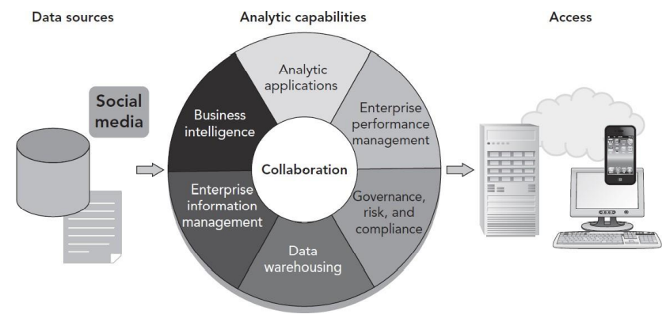

* Also referred to as business analytics
* A range of different applications and technologies used to extract and analyze large amounts of data to aid in decision making
* Includes data-mining tools and querying tools
* Often interactive and visual
* BI technologies are capable of handling large amounts of unstructured data to help identify, develop and create new strategic business opportunities

### In-Memory Computing

* Data in a data warehouse are structured as **multidimensional data cubes**
  + Allow for relationships in the data to be analyzed quickly
* Two main challenges with multidimensional cube structure
  + technical expertise is needed to construct a cube
  + A multidimensional cube necessarily restricts how the data can be analyzed
* Accessing data from memory much faster than accessing data from a hard disk
* Reason why data warehouses use disk memory: storage capacity
  + Hard disks can store one thousand times more data than memory for a comparable cost
* Data compression provided by column storage
  + Makes it possible to store large volumes of data in memory without aggregation
  + Multidimensional cubes are not required
* Both SAP’s and Oracle’s in-memory solutions (SAP S/4 HANA and Oracle Exalytics) are designed to analyze “big data”
* Big data
  + Enormous amount of data available for BI use from all the sources, including:
    - ERP systems, Web sites, databases, scientific research, Twitter, and other social networking applications

### Mobile Computing

* Increasing use of smartphones, tablet computers
* Mobile applications need to be developed for different kinds of smartphones, with different operating systems
* Companies need to make many decisions about the use of mobile devices by employees
* Mobile devices provide users with information and can also be sources of information

### From Internet-Enabled to Cloud Computing

* Cloud computing
  + Delivery of a software product to a user via the Internet
  + The user typically accesses the cloud product through a Web browser or a lightweight (meaning small and simple) application for a computer or mobile device
* Cloud computing is not a completely new concept
  + It represents the latest stage of the development of computing and the Internet

SaaS: Software As A Service

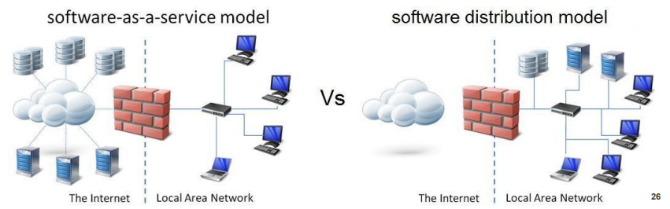

* ▪ A software product is hosted by a company—such as SAP—on its servers and is accessed by customers via a Web browser
* ▪ Sometimes described as a utility
* ▪ A subset of cloud computing

### SAP Business ByDesign

* ▪ An example of SaaS for the ERP market
* ▪ A full ERP system delivered to customers via the cloud
* ▪ For small to medium-sized companies:
  + Lowers the total cost of ownership of the software
  + Enables a rapid and implementation

### Advantages & Disadvantages

#### Advantages:

* Initial affordability
  + Lower cost to implement software provided through SaaS
* Shorter implementation time
  + Implementation time shorter as the user does not have to worry about technical issues
* Lower support costs and complexity
  + Do not need to hire additional IT personnel to implement new systems and applications

#### Disadvantages:

* Security
* Bandwidth/response time
* Flexibility
* No frills
* Technical, not business focus

## Case Study

### Option 1: Buying Computers and Software Rights for an ERP System

own ERP system:

* Database server
* Application server
* PCs
* Computer maintenance
* Licensing rights
* Installation
* User training
* Ongoing consulting
* Network and database administrator

### Option 2: Using an SaaS Provider to Deliver ERP Software

SaaS provider to deliver ERP software:

* PCs
* Computer maintenance
* Software through the SaaS provider
* User training

### Making a Recommendation

* Calculate the NPV(net present value)
* used to compare outlay of funds
* NPV calculation allows different future expenses or earnings
* Hurdle rate
  + Rate of discount over the period
  + Minimum acceptable rate of return on a project